Lab #02: Systems - Stability

EE-3221/051 Digital Signal Processing

Dr. Marek Trawicki

By: Andrew Iliescu, Eduardo Diaz Barragan, & Than Win

January 9, 2019

Introduction

Systems are a combination of components and interconnection for performing a desired task and can be analyzed as mathematical models to understand the resulting output. They have several properties such as linearity, causality and stability, which all have various means of testing. An example is using the discrete-time signals that make up sound clips as inputs to test the stability of a system. The stability of a system is a property that states that every bounded input signal produces a bounded output signal. This lab studies the stability of a several systems by using a sound clip of a train and uses Matlab as a visual tool to help better understand the system.

Procedure

Materials:

* Laptop with MATLAB Software
* Earbuds or headphones

MATLAB Procedure:

* Load and listen to the train sound clip using the load and sound commands
* Graph the train as discrete-time signals and continuous-time signals
* Analyze and label the appropriate quantities on the plot
* Apply an amplitude scaling operation to the chirp discrete-time input signals
* Solve a FIR system with the train sound clip as the input signal
* Listen, graph (2 x 1 plot), and analyze to the results
* Solve an IIR system with the train sound clip as the input signal with the given parameters
* Listen, graph (4 x 2 plot), and analyze to the results

Results

Using the load and sound commands from MATLAB, the sound clip of the of the ‘train’ was played, producing the sound of a train whistle found on older trains. The sound quality was nice and clear. The file was loaded onto a variable ‘S,’ the ‘.’ operator was used to access information such as the sample frequency. The discrete and continuous-time boundaries were set, and two graphs were created using the stem command.



Graph 1: Original train Signal

Graph 1 presents the pair of discrete and continuous time signals for the original sound clip of a train. The length of the sound clip is just under 1.6 seconds. The discrete-time input signal is on top and shows the relationship between continuous-amplitude vs the discrete-time. The continuous-time signal is on the bottom and shows the relationship between continuous-amplitude and continuous-time.

This discrete input signal was then processed through a FIR system with the equation



The coefficients taken from the terms in were defined and grouped into vectors, which are used in the evaluation of the output. The coefficients are listed as  The *filter* command, which filters the input data using the defined numerator and denomination coefficients *b* and *a*, was used to produce a continuous-amplitude versus continuous-time output for both the input and output signal as shown in Graph 2. Concerning the sound of the modified clip, it sounds slightly different in the way where the tone is deeper and is not as sharp as the original.



Graph 2: Input and Output Plots for the FIR system of the train sound signal

Graph 2 shows the continuous-amplitude versus continuous-time input and output sound signals. The top is the input signal (original sound signal), and the bottom is the sound signal after going through the FIR system, . The difference between the two is that the amplitude of the output signal is higher which is the reason why the sound clip sounded deeper. The length is the same, and the visual graph resolution is the same, but the auditory resolution is different. The modified sound clip does not sound as clear as the original clip.

This input was also put into an IIR system with the equation



With the IIR system, the given parameters were implemented, resulting in eight different graphs. One input plot and seven output plots, since there are seven different coefficients; per the parameters. The parameters were defined as



and the result plots are shown in Graph 3. Concerning the auditory characteristics, as the coefficient increased, the pitched increased causing a higher tone. The length of the sound stayed the same except for the last two. It’s important to note that in the equation, the polarity of the coefficient is changed.



Graph 3: Input and Output Plots for the IIR with the Defined Parameters

Graph 3 plots eight different signals. The first, in the top left corner, is the original input train sound signal, and the following are modified versions that have gone through the IIR with the specified coefficient. As the coefficient gets larger the amplitude gets larger. The last two cases are interesting because since the coefficient is 1 and greater than 1, resulting in a negative coefficient greater from the IIR system, you get results different from the rest.

Conclusion

In conclusion, the laboratory was a success because MATLAB was used to listen, graph, and analyze the impact that a FIR and IIR system can have on a sound clip. Depending on what kind of stability is wanted, the FIR (stable) or IIR (unstable) system is used, the coefficients, and initial conditions given determine the result of the modified sound clip. These systems are just a combination of several signal operations so it can lead to more advanced and specific signal modification, compared to an induvial signal operation. This type of systems are incredibly helpful in modifying audio, video, and circuits involving digital signals.

Questions & Answers

1. Load and listen to the original built-in discrete-time input signal *x[n]* called gong into the Command Window using the load and sound commands in Matlab. Graph the gong signal as the discrete-time input signal *x[n]* (continuous-amplitude versus discrete-time) and continuous-time input signal *x(t)* (continuous-amplitude versus continuous-time) using the stem and plot commands in a 2 x 1 plot. Label all the appropriate quantities on the plots. Comment on the results.

Using the load and sound commands from MATLAB, the sound clip of the of the gong was played, producing the sound of a train whistle found on the older generation of trains. The file was loaded onto a variable ‘S,’ the ‘.’ operator was used to access information such as the sample frequency. The discrete and continuous-time boundaries were set, and two graphs were created using the stem command and are shown in graph 4.

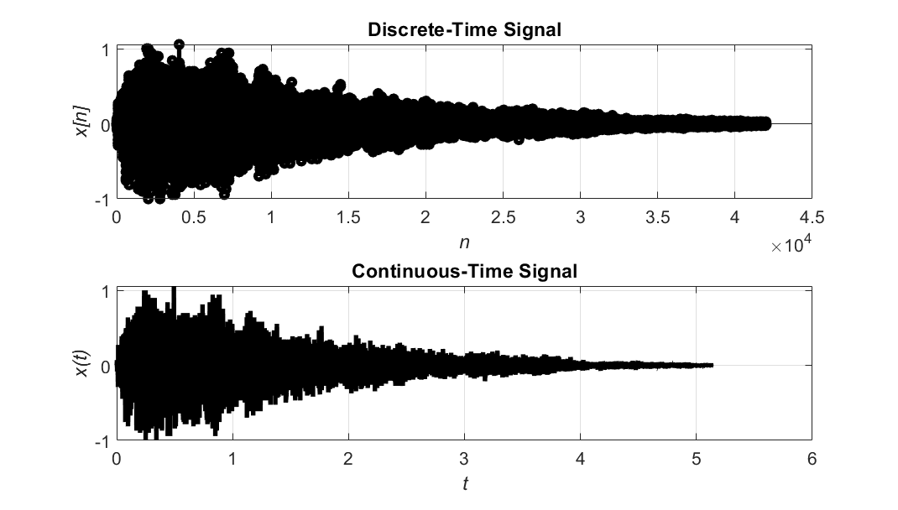

Graph 4: Original gong Signal

Graph 4 presents the resulting plots of the gong signal in both discrete and continuous time. Comparing the two plots, the continuous-time signal is more pixelated and the slight difference in spacing which may be due to the complexity of the continuous-time signal.

1. Given the gong discrete-time input signal *x[n]*, solve the FIR system



for the discrete-time output signal y[n]. Listen to the discrete-time output signal y[n] using the second command. Graph the continuous-time input signal *x(t)* (continuous-amplitude versus continuous-time) and continuous-time output signal *y(t)* (continuous-amplitude versus continuous-time) using the plot command in a 2 x 1 plot. Label all the appropriate quantities on the plots. Comment on the results.

Similar to what was done in the lab, the given coefficients from the newly created equation was defined and grouped so it could be filter with the input gong sound signals. This equation was derived from :



Comparing the two sound clips through auditory observation, the new sound clip is longer, the sound quality is not as sharp, and. After going through the FIR system, the sound clip was slowed, resulting in a longer, a low resolution, and deeper sounding sound clip. These new signals were then plotted in Graph 5.

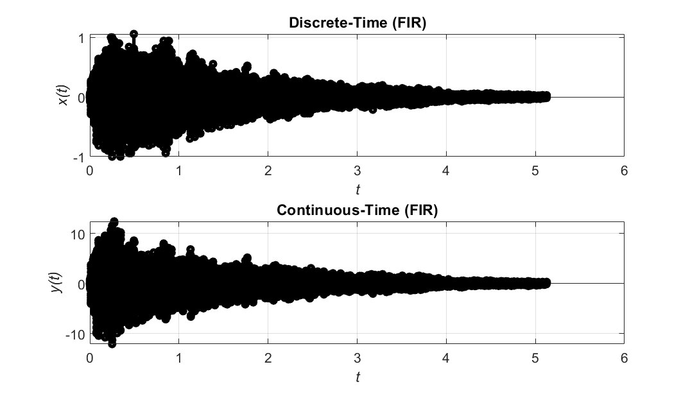

Graph 5: Gong sound signals after going through the FIR system

Graph 5 shows the discrete and continuous time signals of the gong after it went through the FIR system. Comparing this pair of graphs to the graphs of the original sound signals, these signals are longer, and the points are more rounded. The continuous time graph shown here has an amplitude scaled by 10 and are not pixelated like the original graphs.

1. Given the gong discrete-time input signal *x[n],* solve the IIR system



with initial conditions *y*[-1]=0 and y[-2]=0 for the discrete-time output signal y[n]. Listen to the discrete-time output signal *y[n]* using the sound command. Graph the continuous-time input signal *x(t)* (continuous-amplitude versus continuous-time), continuous-time output signal *y(t)* (continuous-amplitude versus continuous-time), and continuous-time error signal  (continuous-amplitude versus continuous-time) using the plot command in a 3 x 1 plot. Label all the appropriate quantities on the plots. Comment on the results.

The gong sound clip was put through another system, but for this case, it was a IIR system with initial conditions. Through auditory observation, the sound clip is like the output of the FIR system. Both sound clips sound slowed down, but this wasn’t as slow as the previous one. The tone of this sound clip is not as deep, is a bit sharper, and not as long. The sound signals and a continuous-time error was graphed and shown in Graph 5.



Graph 5: Gong Sound Clip after going through an IIR system

Graph 5 presents the gong sound clips after going though and IIR system, and the continuous-time error plot. Comparing the FIR and IIR graphs, they both have the same sound length, but the amplitude is a bit different. The amplitude of the IIR continuous-time output is the same as the original sound signal; it is now scaled by 10 like the FIR graph. The continuous-time error plot is used to show the error of the signal, which is translated as the difference between the input and output sound signals. It’s used to visual the difference.